**CT findings in COVID-19:**

1. Early stage (0-4 days after onset of the initial symptom) – subpleural ground glass opacities, unilateral or bilateral. May be patchy or nodular.

2. Progressive stage (5-8 days after the onset of the initial symptom): bilateral multi-lobe distribution with diffuse GGO, crazy-paving pattern and consolidation

3. Peak stage (9-13 days after the onset of the initial symptom): Progressive dense consolidation, diffuse GGO, crazy-paving pattern, consolidation, and residual parenchymal bands.

4. Absorption stage (≥14 days after the onset of the initial symptom): Consolidation gradually absorbed. No crazy-paving pattern was present anymore. Extensive GGO could be observed. Absorption stage extended beyond 26 days from the onset of initial symptoms.

1. Ground glass opacity b. Crazy paving c. Consolidation

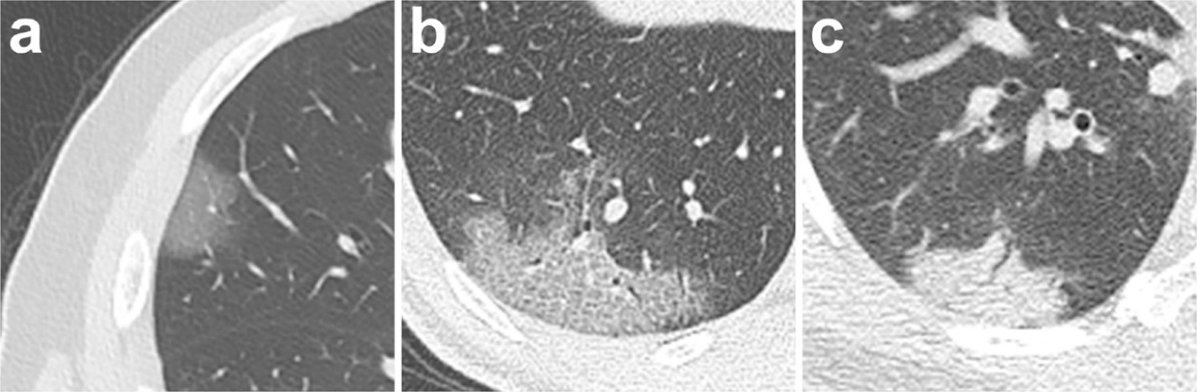

(Images from: Pan et al. Time course of lung changes on chest CT during recovery from 2019 novel coronavirus (COVID-19) pneumonia. Radiology 2020. <https://doi.org/10.1148/radiol.2020200370>)

Nonspecificity of findings: In imaging diagnosis, COVID-19 is difficult to distinguish from pneumonias caused by influenza A or B virus, cytomegalovirus, adenovirus, respiratory syncytial virus, SARS-CoV, MERS coronavirus, and other viral pneumonias. The differential diagnosis can include bacterial pneumonia, although multifocal opacities in bacterial pneumonia are more likely to be consolidative rather than ground glass. Mycoplasma pneumonia (more common in children and adolescents, rarely seen in adults) typically includes bronchial wall thickening and centrilobular nodules.

The Society of Thoracic Radiology has made available a truly excellent presentation on COVID-19.  <https://veritastv.org/programs/covid-19>.  If you jump forward to 30:05 there is a great series of various cases of COVID-19 on chest CT.  They scroll through whole chest CTs with case description and walkthrough. If you have trouble with the direct link, this link will get you to the STR page; the COVID presentation is at the top of the page. <https://thoracicrad.org/?portfolio=education>

**Guidelines for reporting:**

If the above-described pattern of CT findings is seen in a patient not currently diagnosed with novel coronavirus infection/COVID-19, suggest the following statement in the Impression:

**Findings are suggestive of viral pneumonia, but are nonspecific and can include influenza and atypical strains such as COVID-19 infection. Differential diagnostic considerations include other multifocal or organizing pneumonia or pneumonitis.**

Radiologist should communicate result to ED provider.

Selected References:

Pan et al. Time course of lung changes on chest CT during recovery from 2019 novel coronavirus (COVID-19) pneumonia. Radiology 2019. <https://doi.org/10.1148/radiol.2020200370>

Dai et al. CT imaging and differential diagnosis of COVID-19. [Can Assoc Radiol J.](https://www.ncbi.nlm.nih.gov/pubmed/32129670) 2020 Mar 4:846537120913033. doi: 10.1177/0846537120913033. [Epub ahead of print]